**Lab: 03**

**Objective: To learn RMI basics: Generate the stubs and skeletons and run client and server.**

**Task 1: Create RMI program in which server performs basic arithmetic operations.**

**Code:**

**RMIInterface.java**

import java.rmi.*;

public interface RMIInterface extends Remote{

public double add(double a,double b)throws RemoteException;

public double div(double a,double b)throws RemoteException;

public double sub(double a,double b)throws RemoteException;

public double mul(double a,double b)throws RemoteException;

public double mod(double a,double b)throws RemoteException;

}

**RMISeverImpl.java**

import java.rmi.*;

import java.rmi.server.*;

public class RMIServerImpl extends UnicastRemoteObject implements rmiInterface{

public rmiServerImpl() throws RemoteException{

super();

}

public double add(double a,double b){

return(a+b);

}

public double sub(double a,double b){

return(a-b);

}

public double div(double a,double b){

return(a/b);

}

public double mul(double a,double b){

return(a*b);

}

public double mod(double a,double b){

return(a%b);

}

}

**RMISever.java**

import java.rmi.*;

import java.rmi.server.*;

import java.rmi.registry.*;

public class RMIServer extends rmiServerImpl{

public rmiServer() throws RemoteException{

}

public static void main(String args[])throws RemoteException{

try

{

String ro="rmi://localhost:1099/arioperation";

rmiServerImpl p=new rmiServerImpl();

Naming.rebind(ro,p);

System.out.println("server is ready");

}

catch(Exception e){

System.out.println(e);

}

}

}

**RMIClient.java**

import java.rmi.*;

import java.rmi.server.*;

import java.rmi.registry.*;

public class RMIClient{

static rmiInterface ari;

static String name="rmi://localhost/arioperation";

public static void main(String args[])throws RemoteException{

try{

int a=Integer.parseInt(args[0]);

int b=Integer.parseInt(args[1]);

ari=(rmiInterface)Naming.lookup(name);

System.out.println("first number:"+a);

System.out.println("second number:"+b);

System.out.println("add:\t"+ari.add(a,b));

System.out.println("mul:\t"+ari.mul(a,b));

System.out.println("sub:\t"+ari.sub(a,b));

System.out.println("div:\t"+ari.div(a,b));

System.out.println("mod:\t"+ari.mod(a,b));

}

catch(Exception e){

System.out.println(e);

}

}

}

**Output:**

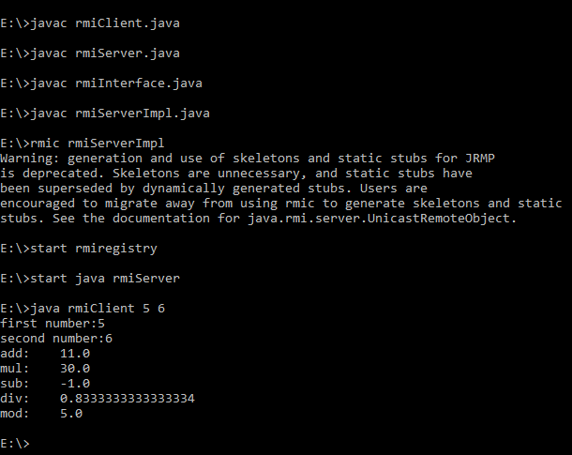

**Task2: Create RMI program in which server sorts the numbers in ascending order.**

**Code:**

**InterfaceSort.java**

import java.rmi.*;

import java.rmi.server.*;

interface interfaceSort extends Remote {

int[] sort( int[] array ) throws RemoteException;

}

**SortServer.java**

import java.rmi.*;

import java.rmi.server.*;

class SortServer extends UnicastRemoteObject implements interfaceSort{

public SortServer() throws RemoteException { }

public int[] sort( int[] array ){

System.out.print( "SortServer.sort() - " );

for (int i=0; i < array.length; i++)

System.out.print( array[i] + " " );

System.out.println();

for (int i = 0; i < array.length; i++){

for (int j = i + 1; j < array.length; j++) {

if (array[i] > array[j]) {

int temp = array[i];

array[i] = array[j];

array[j] = temp;

}

}

}

return array;

}

}

**RmiSortServer.java**

import java.rmi.*;

import java.rmi.server.*;

public class RmiSortServer{

public static void main( String args[] ){

try {

Naming.rebind( "rmi://localhost/SortServer", new SortServer() );

}

catch(java.net.MalformedURLException ex) { ex.printStackTrace();}

catch (RemoteException ex) { ex.printStackTrace();}

System.out.println( "SortServer bound in rmiregistry" );

}

}

**SortClient.java**

import java.rmi.*;

public class SortClient{

public static void main( String args[] ){

int[] array = new int[15];

java.util.Random rn = new java.util.Random();

for (int i=0; i < array.length; i++) array[i] = rn.nextInt(20) + 1;

for (int i=0; i < array.length; i++) System.out.print( array[i] + " " );

System.out.println();

try {

interfaceSort sorter = (interfaceSort) Naming.lookup( "rmi://localhost/SortServer" );

array = sorter.sort( array );

} catch (NotBoundException ex) { ex.printStackTrace();}

catch (java.net.MalformedURLException ex) { ex.printStackTrace();}

catch (RemoteException ex) { ex.printStackTrace(); }

for (int i=0; i < array.length; i++) System.out.print( array[i] + " " );

System.out.println();

}

}

**OUTPUT :**

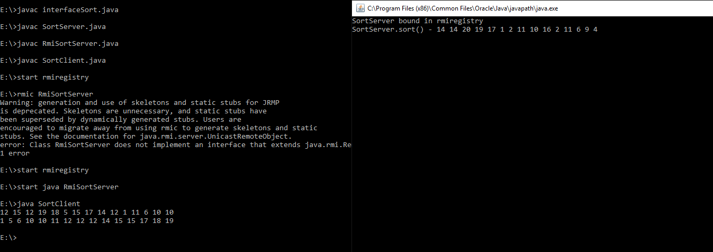

**Task3: (Optional Task) Write an RMI program to implement the Map/Reduce concept of Hadoop on the server program. In other words the client program asks user to provide multiple sentences and send to server, server sends back the word counts.**

**Code:**

**WordCountInterface.java**

import java.rmi.*;

public interface wordCountInterface extends Remote {

public String wordCount(String data) throws RemoteException;

}

**wordCountImpl.java**

import java.rmi.*;

import java.rmi.server.*;

public class wordCountImpl extends UnicastRemoteObject implements wordCountInterface {

public wordCountImpl() throws RemoteException {

super();

}

public String wordCount(String data) {

String print="";

String[] keys = data.split(" ");

String[] uniqueKeys;

int count = 0;

System.out.println(data);

uniqueKeys = getUniqueKeys(keys);

for(String key: uniqueKeys)

{

if(null == key) {

break;

}

for(String s : keys){

if(key.equals(s)) {

count++;

}

}

System.out.println("Count of ["+key+"] is : "+count);

print+="Count of ["+key+"] is : ["+count+"]\n";

count=0;

}

return print;

}

public static String[] getUniqueKeys(String[] keys){

String[] uniqueKeys = new String[keys.length];

uniqueKeys[0] = keys[0];

int uniqueKeyIndex = 1;

boolean keyAlreadyExists = false;

for(int i=1; i<keys.length ; i++){

for(int j=0; j<=uniqueKeyIndex; j++) {

if(keys[i].equals(uniqueKeys[j])){

keyAlreadyExists = true;

}

} if(! keyAlreadyExists) {

uniqueKeys[uniqueKeyIndex] = keys[i];

uniqueKeyIndex++;

}keyAlreadyExists = false;

} return uniqueKeys;

}

}

**wordCountServer.java**

import java.rmi.*;

import java.rmi.server.*;

import java.rmi.registry.*;

public class wordCountServer extends wordCountImpl{

public wordCountServer() throws RemoteException{}

public static void main(String args[]) throws RemoteException{

try{

String ro = "rmi://localhost:1099/wordCount";

wordCountImpl p = new wordCountImpl();

Naming.rebind(ro,p);

System.out.println("Server is ready!");

}catch ( Exception e){

System.out.println(e);}

}

}

**wordCountClient.java**

import java.rmi.*;

import java.rmi.server.*;

public class wordCountClient{

static wordCountInterface wc;

private static String data;

static String name="rmi://localhost/wordCount";

public static void main(String args[])throws RemoteException{

try{

if (args.length > 0){

System.out.println("Send some sentence to server:");

for (String value:args)

data += value;

System.out.println(data);

}

wc=(wordCountInterface)Naming.lookup(name);

String result = wc.wordCount(data);

System.out.println("Count:" + result);

}

catch ( Exception e){

System.out.println(e);}

}

}

**Output:**

